Frank Pasqualini

Carl Bodenschatz

STAT 1223

27 Feb 2019

Spotify Music Library Regression Analysis

This study is going to be conducted to build a multivariate regression model relating multiple attributes of a track to a specific user’s musical preferences. The response variable will be a play count, the amount of times that the user has listened to that song. We believe that a play count is a good estimate of how much a user likes a track, because if they like the track they will listen to it more. It is not a perfect estimate, however, because it is possible for a user to have discovered a track recently that is one of their favorites, but due to not having known about it for a long period of time the play count would be low. The reverse is also true, where a user could have a song that they think is okay but not one of their favorites, but since it has been in their library for years, they have listened to it more times. It is very difficult to quantify how much a user likes a track, and we believe that play count is the best estimate we can currently research. We think these results will be particularly interesting, because if this study is successful, it could be turned into a generalized tool that a user could insert the data from their own music library into. The resulting regression model could be then used on a per-individual basis to find songs that it is likely that the individual would enjoy listening to, by giving recommendations for songs that would maximize the response variable based on the predictors.

For this study, we will be performing the regression on the music library of Frank Pasqualini, using data from his Spotify and Last.fm accounts. At the time of writing this essay, Frank has 5,773 tracks saved to his Spotify library and 35,807 scrobbles saved to his Last.fm account from 1,334 artists. A scrobble is a recorded instance of a track being played. Frank has been tracking his scrobbles using Last.fm since December of 2017, and those scrobbles were tracked directly by linking his Last.fm account to his Spotify account, so the data should be mostly valid even though the predictors will be collected from a different source than the response. We are looking into using 15 potential predictor variables, which are as follows: duration_ms, explicit, popularity, key, mode, time_signature, acousticness, danceability, energy, instrumentalness, liveness, loudness, speechiness, valence, and tempo. These results will be retrieved for each track using Spotify’s Web API.

Duration_ms is a measurement of the length of the track in milliseconds. Explicit is a categorical variable that tells whether the track has been marked to contain vulgar language. Popularity is an integer value between 0 and 100 that is a calculated by one of Spotify’s algorithms based on total plays and how recent those plays are. Key is a categorical variable representing the musical key the track is estimated to be in, with 0 being C, 1 being C#/D♭, all the way up to 11 representing B/C♭. Mode is another categorical variable with 0 representing if the track is in a minor key and 1 if the track is in a major key. Time_signature is an estimation of how many beats are in each bar. Acousticness is a confidence measure of whether the track is acoustic. It has the distribution featured in Figure 1. Danceability is an estimate of how well suited a track is for dancing to, and has the distribution shown in Figure 2. Energy is an estimate of the intensity of the track, and has the distribution featured in Figure 3. Instrumentalness is a confidence measure of whether the track contains vocals and has a very skewed distribution represented by Figure 4. Liveness is a confidence measure of whether there is a live audience in the recording and has the distribution in Figure 5. Loudness is the measure of the average decibel value of the track and has the distribution in Figure 6. Speechiness represents the exclusivity of speech in the track, and high values are almost entirely speech while low values contain little speech but possibly sung words. It has the distribution featured in Figure 7. Valence is a measure of the “happiness” of a song and has the distribution in Figure 8. Finally, tempo is the estimated beats per minute of the track and has the distribution in Figure 9. Almost all the variables described above are retrieved from the “Get Audio Features for a Track” Spotify API call. The documentation for this API call gives in depth descriptions about what each of these values represent, as well as providing the distributions that we have included below.

The data for this study will be collected with a python script which will parse the entire library, get the audio features for each track returned, and use Last.fm’s API to get the play count. The population is defined as all songs the user could like, and the sample will be a random sample of 1000 from the user’s library. We picked 1000 because it is a large enough sample size that the results will be significant, but it is not so big that the analysis takes too long to run. Unfortunately, this sample will be biased towards songs with higher play counts and popularity, because the user is more likely to have added songs to their library if they have heard the song multiple times before, which is familiarity bias.

We will be trying to create the best fit regression model using the 15 variables defined earlier. It is very unlikely that the correlations will be linear for most of the variables, so we might have to manipulate the variables. For example, in the tempo distribution supplied by Spotify, the value peaks at about 120. Perhaps instead of using the variable [tempo] for this, the variable [(tempo-120)2] would be more appropriate, because it peaks at 120 and decreases the farther you get from 120, which would give more of a linear relationship for regression to analyze. It will take some time and a little bit of trial and error to find the correct variables (if the correct variables even exist) but taking that time will help improve the model. We also plan on comparing the distributions from our sample to the distributions provided by Spotify. Because Spotify doesn’t supply the exact numbers, they will have to be estimated by measuring the distributions, which could cause some error. We plan on testing the Null hypotheses that the means and standard deviations of all the samples are equal to the means and standard deviations of their populations given by Spotify.

We hope to conclude whether Frank’s music library’s attributes differ significantly from the population averages and whether a good fitting model can be made to predict how much a user would enjoy a song. Right now, the script for scraping the data is already written. We have the barebones script for analysis, and we plan to have most of the analysis script done by March 10th. We will then use the data collected from that to figure out what the best variables for regression analysis would be and build a model with recursive backtracking to find the best fit. The model should be finalized by March 24th. The remaining time will be used to write up the final report using the results we collected.

Figures

Figure 1

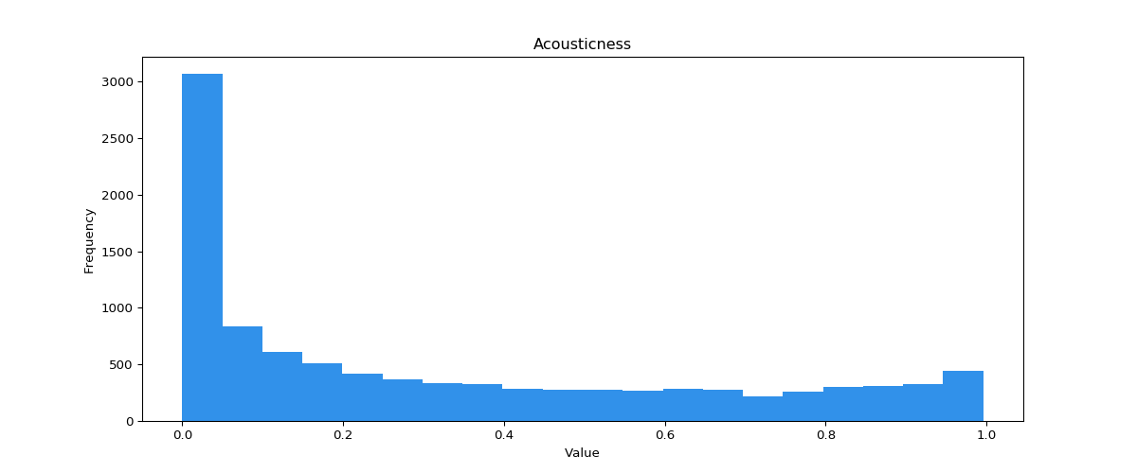

Figure 2

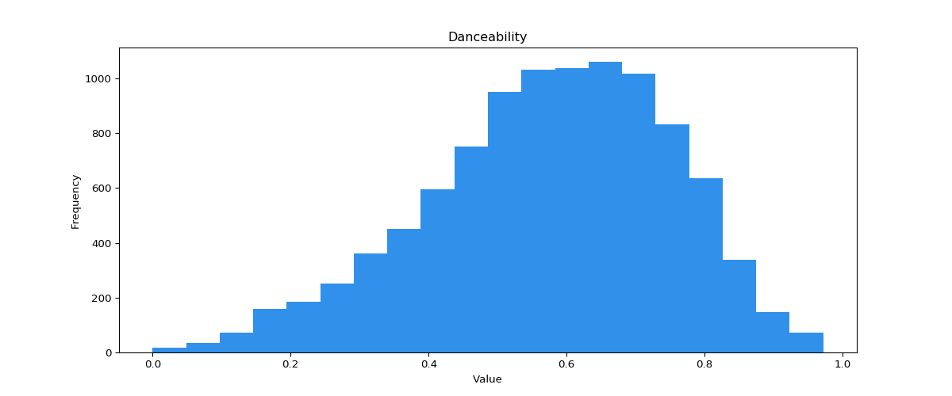

Figure 3

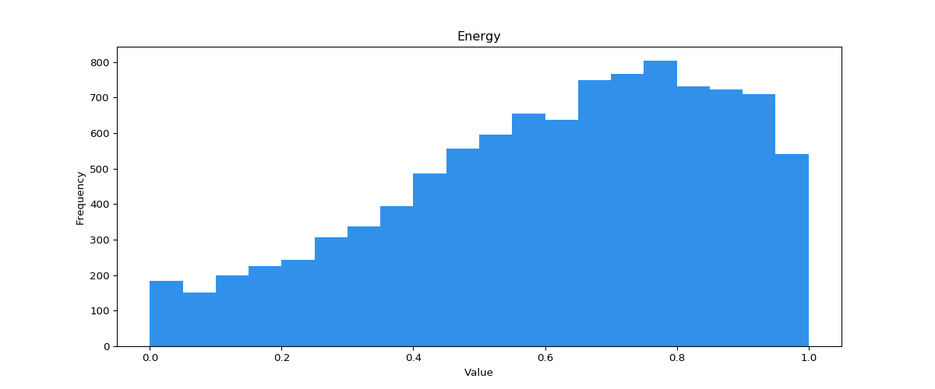

Figure 4

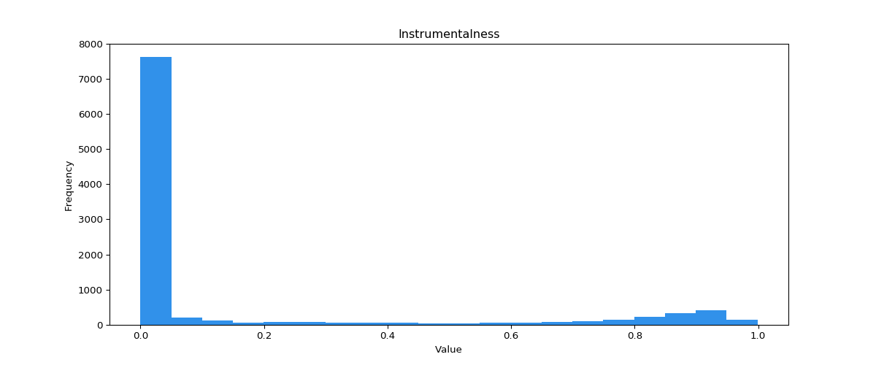

Figure 5

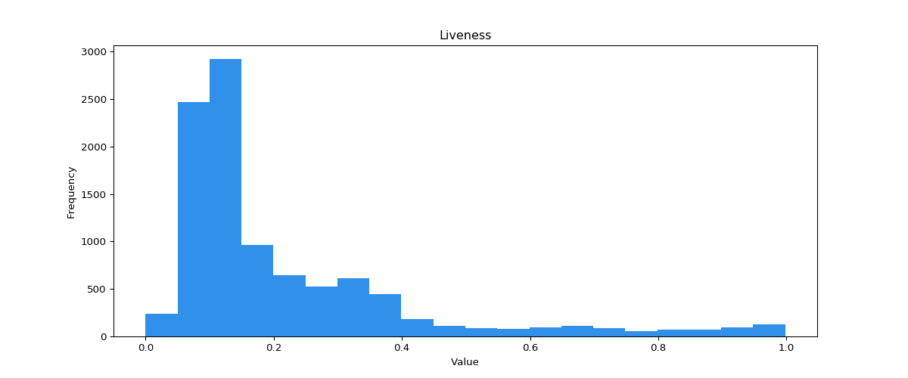

Figure 6

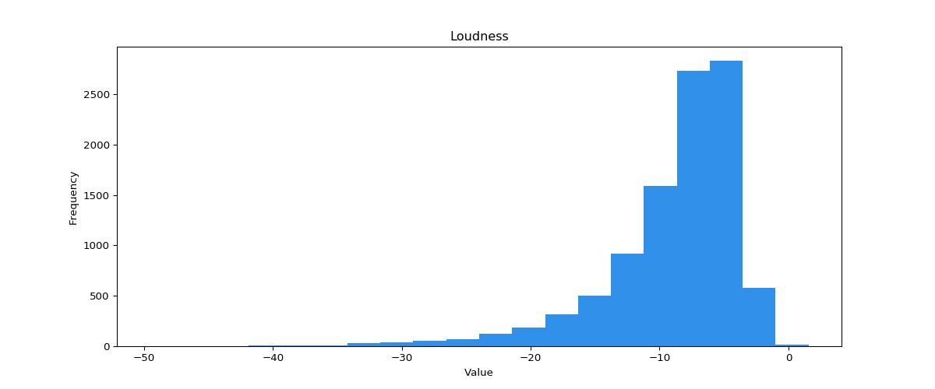

Figure 7

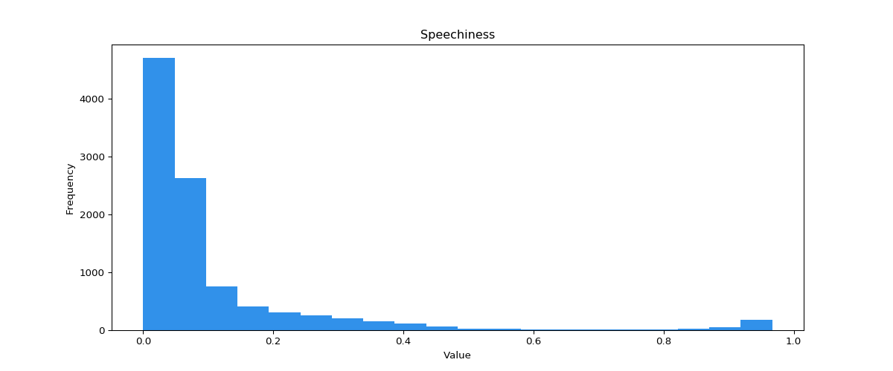

Figure 8

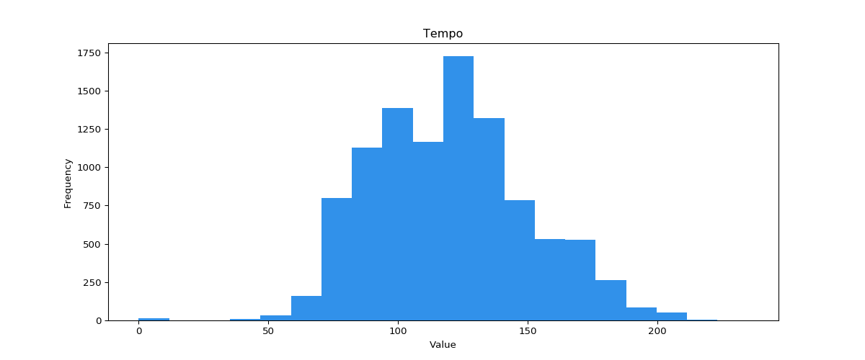

Figure 9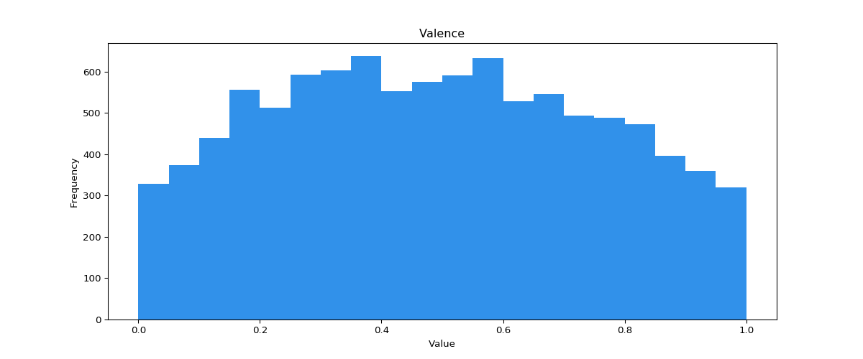

Works Cited

“Get Audio Features for a Track.” Spotify for Developers, developer.spotify.com/documentation/web-api/reference/tracks/get-audio-features/.